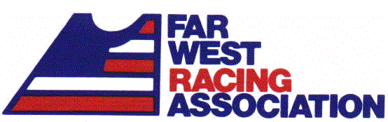 | 2021-2022 RACING SEASON  REGISTRATION FORM  (PLEASE PRINT)  ID #:

Sex: Name:

DOB: Age (as of 12/1/21):

Phone (Hm):

Phone (Wk or Cell):
eMail:
Home League |  |  | Discipline | Self  Bump | Age Class | Skill Class
Central  Rokka  San Diego  Schusski  Ullr | BAC Open  BAC Singles  NBR  PACRATS  Sierra  Open (no league) |  | Skier  Snowboarder  Both |  | Vet (50 +)  Open (18-49)  Jr (0-17)  The age class you check, will be the age class you race in for all League races during the season. | 1  2  3  4  5  6  7  8  9  10 | Jr 1  Jr 2  Beginner  FTR*  SNOB1  SNOB2  Unrecables
Each racer must choose a “HOME” league. You may race for multiple leagues during the season, but the “HOME” league is the one that will have the first right to select you for their championship team. If you are selected by the league you checked above, you must race for them or be disqualified. If you are not selected by your “HOME” league, you may race for any other league that invites you to race for them.
 |  |  |  | Best Two HDCPs |  |  | Strike In
Home Club (Also Racing for Clubs Below)

Rokka | Schusski | Ullr
Beach Cities  Cliff Hangers  Edelweiss  Grindelwald  Los Padres  Unrecables  Wailers  Westwood  Open (no club) | Auslich  Balboa  Flatlands  Huntington Beach  Orange County  Snow Bounders  Snow Fliers  Shooters  Tri-Valley  Vand Bakke  Open (no club) | 4 Seasons West  Aerospace  Century City  Conejo  Hump Jumpers  LA Asian  Long Beach  Recreation  Tri-Valley  TRW  Winter Fox  Open (no club) |  | Key: B=Rokka&Ullr/S=Socalcs/F=FarWest  Date Bib Class HDCP Stk
 | San Diego
Action
Don Diego
North Island Snow Drifters
San Diego
Solar/Sundstrand
Torrey Pines
Open (no club)

* FTR = First-Time Racer, no Handicap in the database (i.e., have not completed a race in the rating period)

