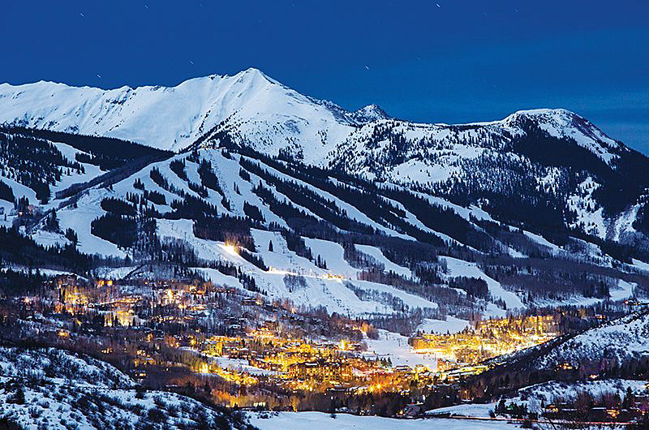

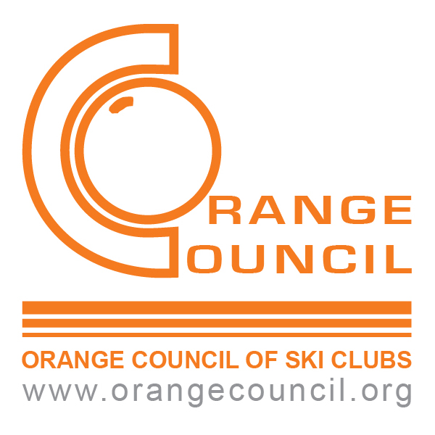

Invites you to join us for

FWSA Ski Week at

Aspen Snowmass

January 29th – Feb.5th, 2022

|  |
| --- |
| FWSA Package  7 Nights Lodging  Pre Trip Party  Welcome Party  Council Dinner  Mountain Picnic, Racing  Dine Around, Dessert Social & Dancing  Awards Apres Ski Party  **Use your IKON pass**  5 Day Lift Ticket, $430  6 Day Lift Ticket, $538  (Srs. Ask trip leader) |
| *Sign up NOW!! Pillows are limited!!!* |

|  |
| --- |
| Stonebridge Inn Hotel  King or 2 Queen Beds  FWSA Amenities  Ski In/out, Restaurants/lounge, Pool and Spa & Fitness facility  $2,110 / person - Dbl Occ. W / Trans  $1,492 / person - Dbl Occ. W/O Trans  Top o’ Village Condos  2 or 3 Bedroom units  FWSA Amenities  Ski in / out, Pool, Hot tub, Workout facility  $2,053/ person - Dbl Occ. W / Trans  $1,435/ person - Dbl Occ. W/O Trans |

***Price for transportation is currently an estimate***

Contact trip Leader: Judy Thurman, 714.883.1216 or ylskicat@aol.com

Make checks payable to: **Orange Council of Ski Clubs**

mail with completed forms to J. Thurman, 20630 Travis Rd., Yorba Linda, 92887

**Initial Deposit: $550 2nd Payment: July 3rd $650 3rd Payment: Sept. 3rd $450**

**Balance Due: November 10th 2021**

Cancellation Penalties: After Jul. 14th, $100 per person, after Aug. 15th, $200 per person, after Sept. 15th the cost of a SS for your pillow. After Dec. 13th No Refunds.

**The Orange Council Board of Directors strongly recommends the purchase of travel insurance**

Orange Council CST# 2083043, TCRF member